Competitor Analysis & Strategic Opportunity Report

1. Introduction
Developer brief, suggest strategic opportunities and development targets, all inspired by leading civic tech platforms (competitors). Includes Q3–Q1 rollout timeline, modular architecture, user onboarding flow. Prototype site launches Q3 2025, volunteers requested to explore GroupBuild's GitHub, Discord, and demo environments and then to suggest immediate contributions.

2. Diagrams
2.1 Identity & Trust Lifecycle
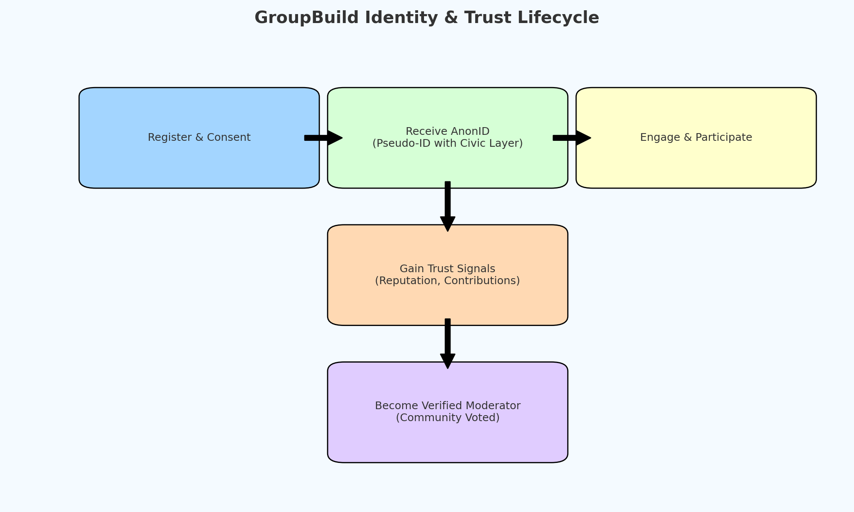
2.2 Civic Participation Funnel
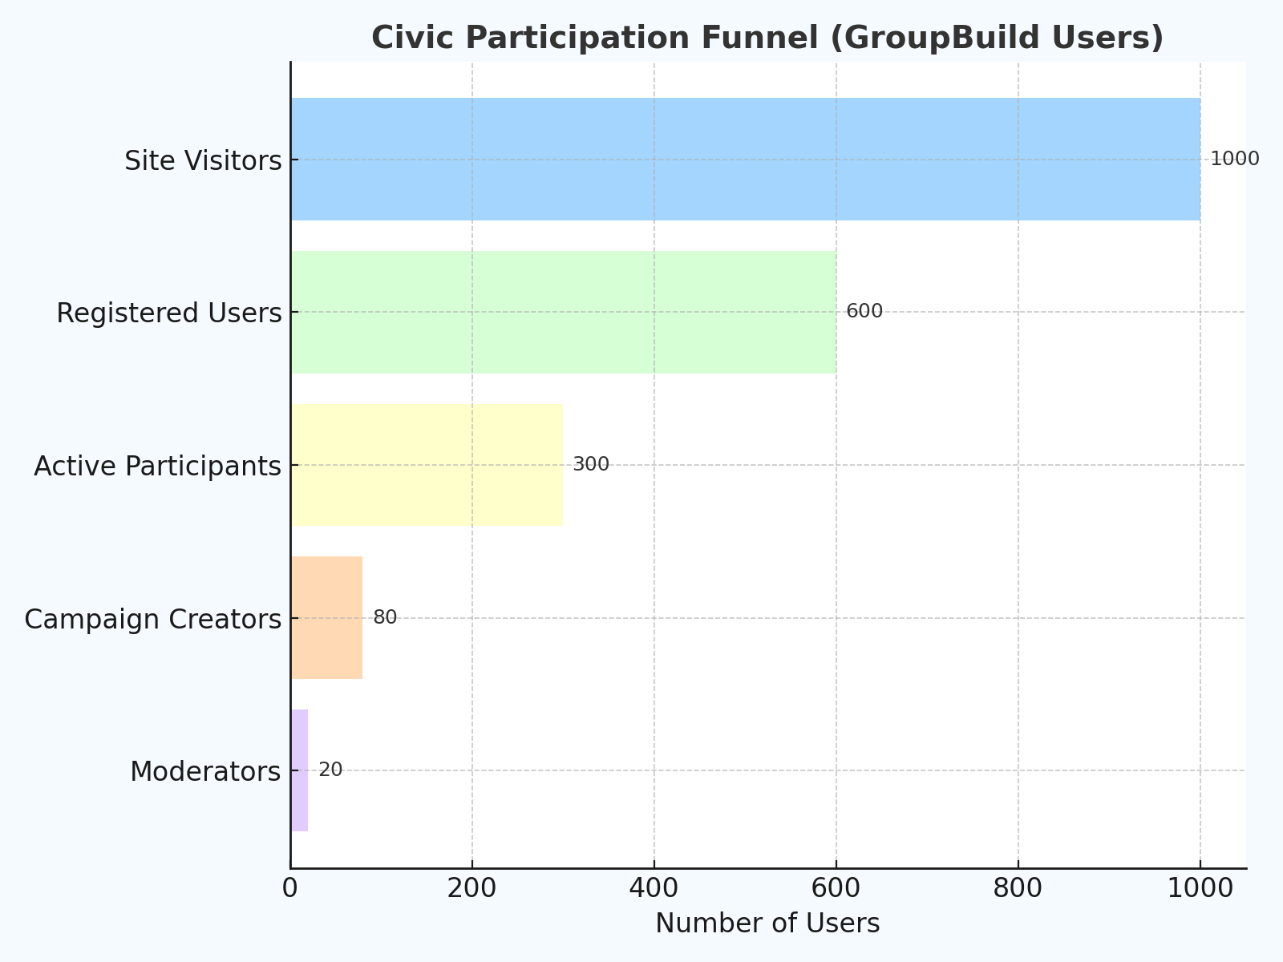
2.3 Feature Adoption Timeline
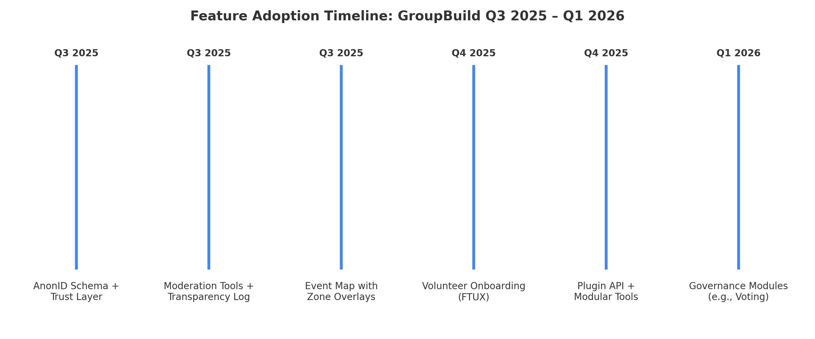
  - Architecture Stack
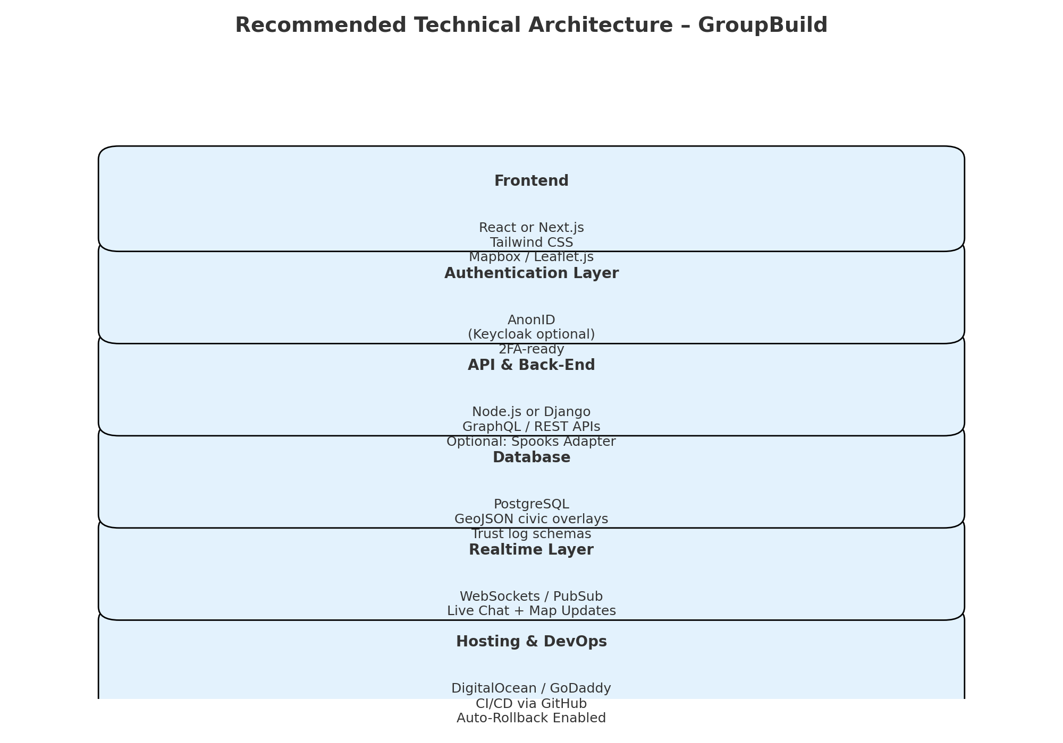

2.5 Plugin System
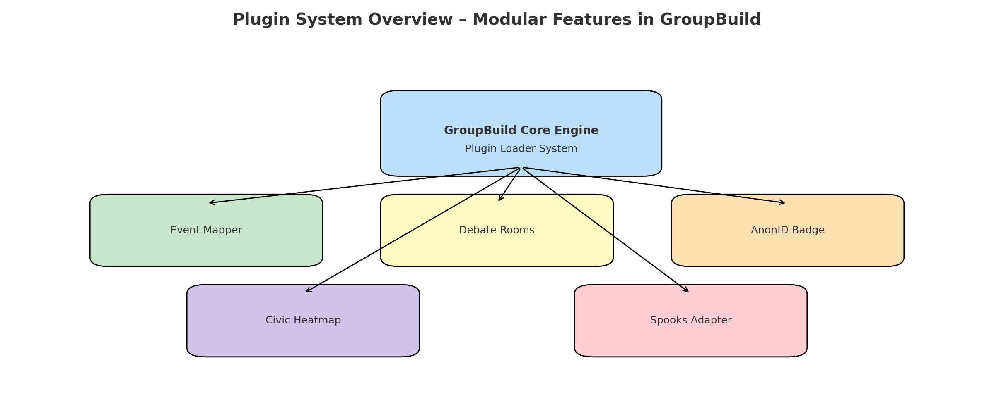
  - FTUX Flow

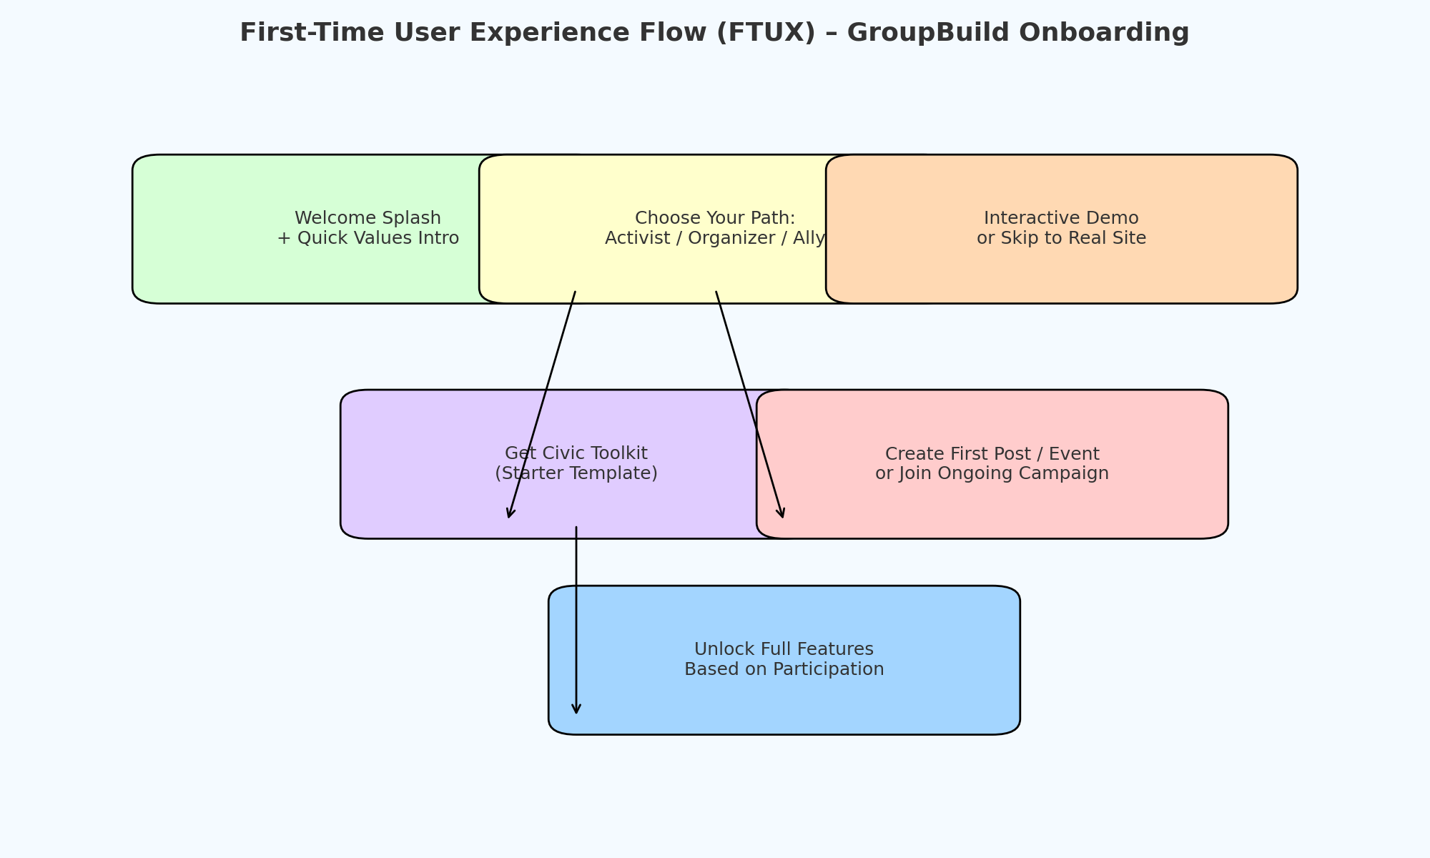
3. Feature Opportunities & Developer Action Items
Secure Pseudonymous Identity
Study Keybase and NymTech (https://nymtech.net/) for modular identity layers. Create the AnonID schema with civic attribute fields and progressive trust layering.
Moderation and Trust Metrics
Use Discourse mod dashboards (https://meta.discourse.org/t/moderator-guide-documentation/134123) as reference. Implement logs of community actions and transparency metrics for all moderation outcomes.
Community Maps & Event Layers
Model after Decidim's participatory mapping (https://docs.decidim.org/). Add editable polygon layers, icon tagging, and auto-generated 'Action Zones' that decay over time.
Guided Campaign Builders
Adapt NationBuilder’s Actions UX (https://nationbuilder.com/features). Develop a drag-and-drop campaign tool with milestones and civic outcome indicators.
Onboarding Flows for New Users
Review Loomio’s helpbot tutorials (https://loomio.school/). Build a branching onboarding path with animated tooltips and starter templates.
Open Plugin Architecture
Use a WordPress-style plugin loader. Reference Decidim’s modular structure. Allow opt-in activation of features like debate rooms, civic heatmaps, and AnonID badges.

4. Assignments for Developers
- Compare Decidim's APIs and participatory budgeting systems.
- Analyze Loomio’s voting modules and transparency levels.
- Reverse-engineer Polis’s clustering and opinion mapping logic.
- Study Eventbrite’s event creation flow and map UX.
- Document Discourse’s trust scoring API and moderation metrics.
- Explore Keybase’s messaging and identity verification flows.

5. Q3–Q1 Feature Adoption Timeline
Refer to diagram 2.3. Each feature is targeted to be rolled out following successful implementation of a Minimum Viable Product, hosted in safe havens, subsequent to a demo site hosted with DigitalOcean or Godaddy which will be mostly designed to help onboard volunteer developers. Quarterly priorities should be informed primarily by user-onboarding needs, and then core civic functionality.

6. Recommended Architecture Stack
See diagram 2.4. The proposed architecture stack features a front-end in React or Next.js, optional Keycloak authentication, GraphQL/REST APIs, PostgreSQL, and real-time pub/sub components. Obviously, all layers should be compatible with modern civic tech needs.

7. Plugin Loader Modules
Diagram 2.5 demonstrates a proposed modular plugin interface. Volunteers may contribute new plugin ideas via GitHub (for code repository) or Discord (for team discussions, feature descriptions, strategy, etc.). Please start with core features, e.g Event Mapper, AnonID Badge, Debate Rooms (Groups).

8. FTUX – First-Time User Experience
See diagram 2.6. This flow helps users enter the platform based on intent. Volunteers should design animated, tool-assisted walk-throughs that match each path: activist, ally, or organizer.

9. Reference Resource Library
Decidim Docs: https://docs.decidim.org/
Loomio School: https://loomio.school/
Polis Civic Tech Guide: https://blog.pol.is/taiwan-case-study
NationBuilder Features: https://nationbuilder.com/features
Discourse Trust Levels: https://meta.discourse.org/t/what-do-user-trust-levels-do/4924
The Tech We Need (RxC): https://www.radicalxchange.org/media/blog/the-tech-we-need-for-collective-self-governance/

